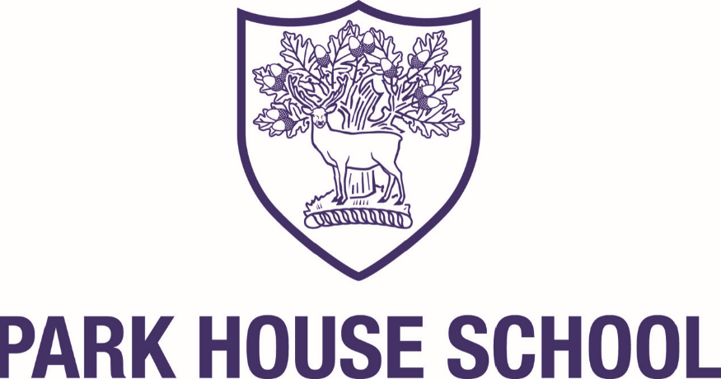

Consultation on the proposed admission arrangements for entry in September 2024/25
In accordance with the School Admissions Code 2021, the Greenshaw Learning Trust is currently consulting on the admission arrangements for Park House School for entry in September 2024/25.

The consultation will be held between Wednesday 9 November and Wednesday 21 December 2022.
The main changes to the admission arrangements are;
- Inclusion of a Supplementary Information Form (SIF) for all exceptional social and medical applications
- Alignment of the order of priorities within the admission arrangements to mirror all other Greenshaw Learning Trust schools
- Amendment of the criteria definitions in line with all Greenshaw Learning Trust schools

Please click here to view the proposed admission arrangements and Supplementary Information Forms.
Responses must be received by the Wednesday 21 December 2022 and should be sent by post or email to;
Head of Admissions
The Greenshaw Learning Trust
Grennell Road
Sutton
SM1 3DY
mfrancis@greenshawlearningtrust.co.uk

